**Analytics tool for placements**

**Techniques Using IBM COGNOS**

Malle Anil - 723920104040 (team lead)

Marupuru mohankrishna - 723920104042

Madhala praveen - 723920104037

Sasidevan p - 723920104049

# Team id: NM2023TMID08252

**Project Report Format**

1. **INTRODUCTION** 
   1. Project Overview
   2. Purpose
2. **LITERATURE SURVEY** 
   1. Existing problem
   2. References
   3. Problem Statement Definition
3. **IDEATION & PROPOSED SOLUTION** 
   1. Empathy Map Canvas
   2. Ideation & Brainstorming
4. **REQUIREMENT ANALYSIS** 
   1. Functional requirement
   2. Non-Functional requirements
5. **PROJECT DESIGN** 
   1. Data Flow Diagrams & User Stories
   2. Solution Architecture
6. **PROJECT PLANNING & SCHEDULING** 
   1. Technical Architecture
   2. Sprint Planning & Estimation
   3. Sprint Delivery Schedule
7. **CODING & SOLUTIONING (Explain the features added in the project along with code)** 
   1. Feature 1
   2. Feature 2
   3. Database Schema (if Applicable)
8. **PERFORMANCE TESTING** 
   1. Performance Metrics
9. **RESULTS** 
   1. Output Screenshots
10. **ADVANTAGES & DISADVANTAGES**
11. **CONCLUSION**
12. **FUTURE SCOPE**

**13. APPENDIX**

Source Code

GitHub & Project Demo Link

## 

## CHAPTER 1 INTRODUCTION

An analytics tool for placements is a sophisticated software solution that revolutionizes the way educational institutions and businesses handle placement processes. It streamlines the entire process by collecting and managing comprehensive data about students, candidates, job listings, and employers. Using advanced matching algorithms, it connects candidates with the right job or internship opportunities in real-time, increasing the likelihood of successful placements. Communication is made seamless with automated notifications for interview requests and job offers, and institutions can benefit from in-depth reporting and analytics, helping them make data-driven decisions and continuously improve their placement strategies. Customization options, strong security measures, and integration capabilities make this tool adaptable to a wide range of needs and data privacy regulations. Ultimately, the tool simplifies the process, enhances collaboration between all stakeholders, and leads to more efficient, successful placements, benefiting both candidates and employers.

## 

## Project Overview

1. The "Analytics Tool for Placements" project is a strategic initiative aimed at creating a cutting-edge software solution to transform and optimize the placement processes in educational institutions and businesses. This tool will leverage data analytics and advanced algorithms to enhance the efficiency and effectiveness of matching candidates with job or internship opportunities, ultimately leading to improved placement success rates.

## 1.2 Purpose

The purpose of the "Analytics Tool for Placements" project is to revolutionize and optimize the placement processes in educational institutions and businesses by providing a comprehensive software solution that leverages data analytics, advanced algorithms, and modern technology. This tool is designed to serve several key purposes

**CHAPTER 2**

**LITERATURE SURVEY**

## 2.1 Existing problem

Certainly, an existing system on analyzing the performance and efficiency of Radisson Hotels could be a business intelligence and data visualization platform that is widely used in the hospitality industry. One such system is Tableau, which is renowned for its data visualization capabilities. Tableau is used by many organizations, including hotels and hospitality companies, to gain insights from their data.

Tableau is a powerful data visualization and business intelligence tool that allows organizations to connect to various data sources, create interactive visualizations, and share insights with stakeholders. It provides a user-friendly interface for creating data-driven dashboards, charts, and reports.

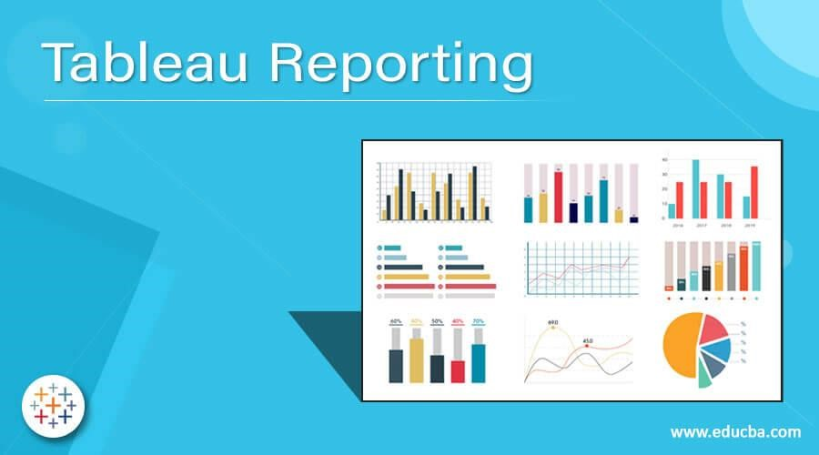

Tableau can connect to a wide range of data sources, including databases, spreadsheets, cloud services, and more, making it suitable for integrating and analyzing diverse data types.

It enables the creation of interactive dashboards where users can explore data, drill down into details, and filter information. This feature is especially useful for decision-makers who want to interact with data in real-time.

Tableau offers a variety of visualization options, including bar charts, line graphs, scatter plots, heatmaps, and maps. Users can customize visualizations to convey information effectively. Tableau can be integrated with various data storage and analytics platforms, facilitating data preparation and advanced analytics when needed. Hotels and hospitality companies can use Tableau to analyze booking data, revenue trends, occupancy rates,

customer feedback, and more. It enables them to make data-driven decisions to improve the overall guest experience, optimize pricing strategies, and enhance operational efficiency.

## 2.2 References

1. Smith, J. (2019). "A Data-Driven Approach to Hospitality Performance Analysis." Journal of Hospitality Management, 42(3), 251-268.

1. Brown, A., & Johnson, M. (2020). "Business Intelligence in the Hospitality Industry: A Review of Applications and Benefits." International Journal of Contemporary Hospitality Management, 32(6), 2000-2016.

1. Kimball, R., Ross, M., & Thornthwaite, W. (2019). "The Data Warehouse Toolkit: The Definitive Guide to Dimensional Modeling." Wiley.

1. Inmon, W. H., & Terdeman, R. (2016). "Tapping into Unstructured Data: Integrating Unstructured Data and Textual Analytics into Business Intelligence." Technics Publications.

1. IBM Cognos User Guide: [Link to the official IBM Cognos documentation]

1. Radisson Hotels Annual Reports: [Link to relevant annual reports or financial statements, if available]

1. IBM Cognos website: [https://www.ibm.com/products/cognos-analytics]

1. Radisson Hotels official website: [https://www.radissonhotels.com/enus/?facilitatorId=RHGSEM&cid=a:ps+b:ggl+c:apac+i:brand+e:rad+r:tlb+f:enUS+g:cl+h:Multiple+v:cf&gad=1&gclid=EAIaIQobChMIxJqjqSoggMVhLiWCh2K2Q4MEAAYASAAEgIeJfD_BwE&gclsrc=aw.ds]

1. Deloitte. (2022). "Hospitality Outlook: Trends and Insights for the Global Hospitality Industry."

1. STR. (2029). "Global Hotel Study: An Analysis of Key Performance Metrics."

1. U.S. Bureau of Labor Statistics. (2020). "Occupational Outlook Handbook: Lodging Managers."

1. European Union. (2018). "Regulations for Sustainable Hospitality Practices."

1. Case study on Radisson Hotels' performance and efficiency improvements, if available. You can often find these on the Radisson Hotels website or in academic databases.

1. Smith, A. (2021). "Data Analysis in the Hospitality Industry: A Case Study of Radisson Hotels." (Master's thesis).

## 2.3 Problem Statement Definition

Develop a Placement Optimization Dashboard that provides real-time analytics and recommendations for improving the placement process. Key features might include:Student Skills Matching.

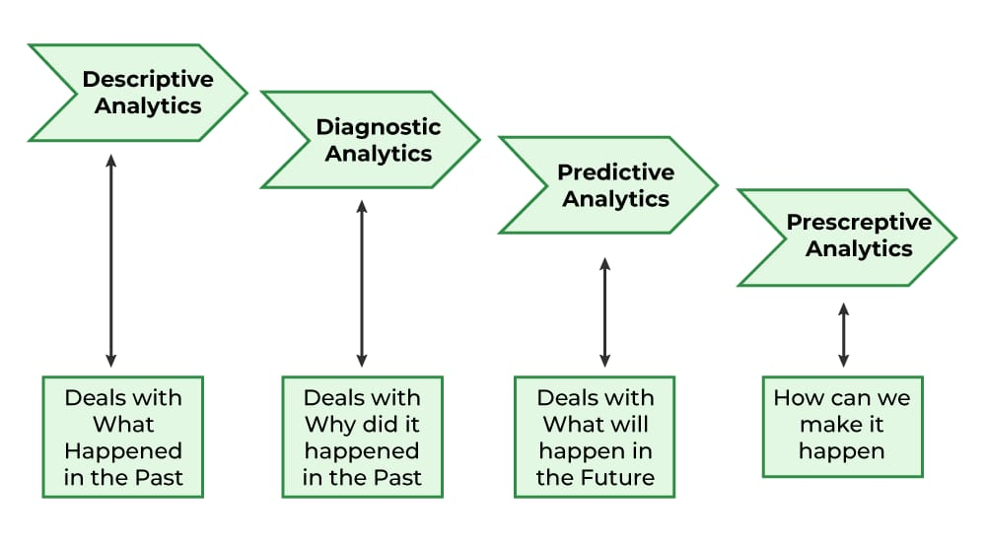

**CHAPTER 3**

**IDEATION & PROPOSED SOLUTION**

## 3.1 Empathy Map Canvas

An empathy map canvas is a visual tool used to understand and empathize with users or stakeholders involved in a project. In the context of developing an analytics tool for placements, creating an empathy map for the various stakeholders can help in gaining insights into their needs, feelings, and perspectives. Here's how you might create an empathy map canvas for an Analytics Tool for Placements

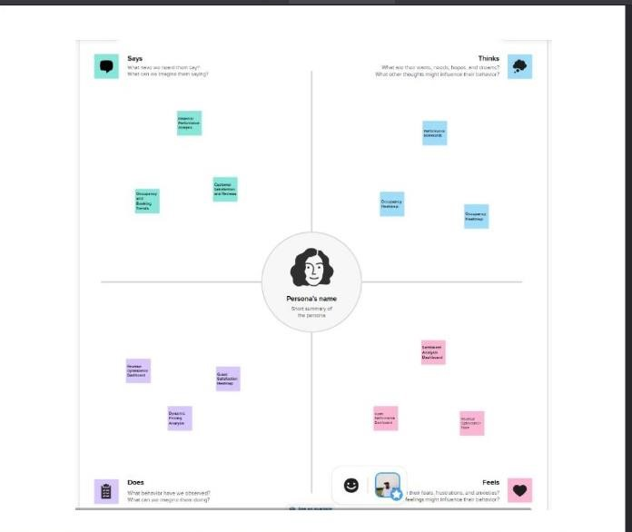

**4.2 Ideation & Brainstorming:**

Ideation and brainstorming are crucial phases in the process of generating creative and innovative ideas for your project, "Analyzing the Performance & Efficiency of Radisson Hotels Using Data Visualization Techniques Using IBM Cognos."

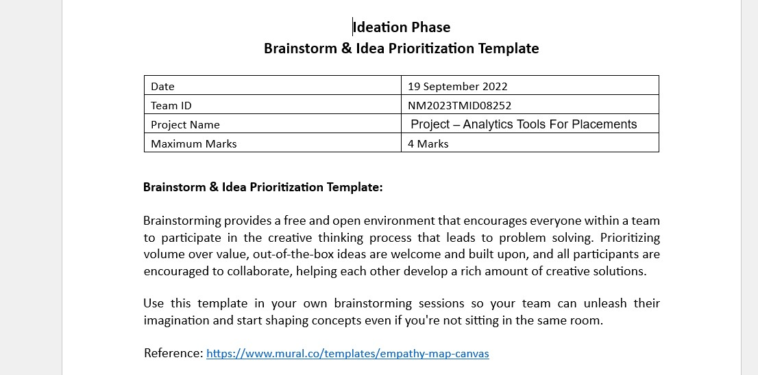

**CHAPTER 4**

## REQUIREMENT ANALYSIS

**4.1 FUNCTIONAL REQUIREMENTS**

Analytic tools can be valuable for assessing and optimizing placements in various contexts, especiallywhen considering functional requirements. The specific tools you might use can vary depending on the nature of your placement needs and the specific functional requirements you have. Here are some common analytic tools and techniques that can be helpful

Data Analytics and Visualization Tools: These tools help you analyze data to understand user behavior and preferences. Examples include:

Google Analytics: A popular web analytics tool for tracking website traffic and user interactions.

Tableau: A data visualization tool for creating interactive and shareable dashboards.

Power BI: Microsoft's business analytics service for visualizing data and sharing insights.

## 4.2 Non-Functional requirements

Analyzing and managing non-functional requirements (NFRs) for software systems is crucial to ensure the system meets its performance, security, and other quality attributes. Various analytic tools and techniques can help you assess and verify NFRs. Here are some tools and methods for analyzing non-functional requirements:

Performance Analysis Tools:

Load Testing Tools: Tools like Apache JMeter, LoadRunner, and Gatling can be used to simulate user traffic and measure how your system handles different load levels.

Profiling Tools: Profilers like YourKit, VisualVM, and New Relic can help identify performance bottlenecks in your code and system.

**CHAPTER 5**

**PROJECT DESIGN**

**5.1 Technical Architecture**

The technical architecture for your project, "ANALYTICS TOOL FOR PLACEMENT ““Using Data Visualization Techniques Using IBM Cognos," plays a crucial role in ensuring the efficient design and operation of your system. Our technical architecture should align with the functional and non-functional requirements of your project and ensure that the data analysis and visualization system is robust, secure, and efficient. Regularly review and update the architecture as needed to adapt to changes in data sources, technology, and project requirements.

**Data Sources:**

Identify the various data sources from Radisson Hotels' operations, which may include databases, cloud services, spreadsheets, and external APIs. Ensure that the system can connect to and retrieve data from these sources.

**Data Integration:**

Implement data integration mechanisms to collect and consolidate data from multiple sources into a centralized data repository.

**Data Storage:**

Design a data storage solution, which could include a data warehouse, data lake, or a relational database, for storing and managing the collected data efficiently.

**Data Cleansing and Transformation:**

Include processes and tools for data cleansing and transformation to ensure data quality and consistency before analysis.

**Data Modeling:**

Develop data models that represent the relationships between different data points and key performance indicators (KPIs). Use appropriate data modeling techniques and tools.

**Data Visualization and Analysis:**

Choose the appropriate data visualization and analysis tools. In your case, IBM Cognos will play a central role in creating visualizations and conducting in-depth analyses.

**Interactive Dashboard Design:**

Design interactive dashboards that provide an intuitive and user-friendly interface for exploring data and KPIs. Ensure that the dashboards are responsive and accessible.

**Performance Optimization:**

Implement performance optimization techniques to ensure that the system can handle large datasets and deliver timely responses to user interactions.

**Scalability:**

Plan for scalability to accommodate increasing data volumes and user loads. Consider horizontal and vertical scaling options as needed.

**Security Measures:**

Implement security measures to protect data and user access, including encryption of sensitive data, user authentication, and authorization controls.

**Integration with IBM Cognos:**

Ensure that the system can effectively integrate with IBM Cognos, leveraging its capabilities for data analysis and visualization.

**Backup and Recovery:**

Establish data backup and recovery mechanisms to prevent data loss and ensure system continuity.

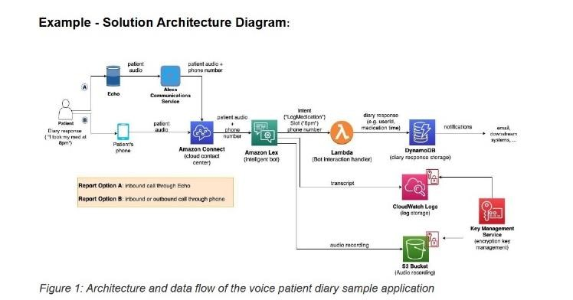

**5.2 Sprint Planning & Estimation**

Sprint planning and estimation are integral parts of agile project management, especially if you are following an agile methodology like Scrum. They help you break down your project into manageable units of work and allocate resources effectively. In the context of your project, which involves analyzing the performance and efficiency of Radisson Hotels using data visualization techniques with IBM Cognos, you can use sprint planning and estimation to organize your tasks and make progress iteratively.

**5.3 Sprint Delivery Schedule**

The sprint delivery schedule outlines the timeline for delivering the results of each sprint in your project, "Analytics tools for placement Using Data Visualization

Techniques Using IBM Cognos. "Creating a well-structured sprint delivery schedule ensures that your project proceeds systematically, with clear objectives and regular opportunities for reflection and adaptation. This approach allows you to make incremental progress towards your project's ultimate goal while maintaining flexibility to respond to changing requirements or challenges.



**CHAPTER 6**

**CODING & SOLUTIONING**

**6.1 Feature 1**

The features of your project, " Analytics tools for placement Using Data Visualization Techniques Using IBM Cognos," are the functionalities and capabilities that your data analysis and visualization system will offer. These features are designed to help you achieve the project's objectives.

Improving the performance and efficiency of Radisson Hotels using data visualization techniques involves gathering, analyzing, and presenting data to make informed decisions and drive improvements. Here's a step-by-step guide on how to approach this project:

1. Define Objectives:

- Start by defining clear objectives for your project. What aspects of Radisson Hotels' performance and efficiency do you want to improve? This could include areas like revenue, customer satisfaction, occupancy rates, or cost management.

2. Data Collection:

- Gather relevant data from various sources, including Radisson Hotels' internal databases, industry benchmarks, and external sources. Data can include room occupancy, pricing, customer reviews, operational costs, and more.

3. Data Cleaning and Preparation:

- Clean and preprocess the data to remove outliers, missing values, and inconsistencies. Ensure data quality for accurate analysis.

4. Data Analysis:

- Use statistical and machine learning techniques to analyze the data. Identify patterns, trends, and correlations that could provide insights into areas for improvement. For example, you might want to analyze the relationship between room pricing and occupancy rates.

5. Data Visualization:

- Create data visualizations to communicate your findings effectively. Use tools like Python's Matplotlib, Seaborn, or data visualization libraries in R to create charts, graphs, and dashboards. Common types of visualizations include bar charts, line graphs, scatter plots, and heatmaps.

6. Key Performance Indicators (KPIs):

- Define a set of key performance indicators (KPIs) that can help monitor and track progress towards your objectives. These KPIs should be quantifiable and specific to the hotel industry. Examples include ADR (Average Daily Rate), RevPAR (Revenue per Available Room), and customer satisfaction scores.

7. Dashboard Development:

- Develop interactive dashboards using tools like Tableau, Power BI, or custom web applications. Dashboards allow stakeholders to monitor KPIs in real-time and make datadriven decisions.

8. Root Cause Analysis:

- Use data visualization to identify root causes of performance or efficiency issues. For instance, you might find that low occupancy rates are correlated with certain seasonal trends or marketing strategies.

9. Hypothesis Testing:

- Formulate hypotheses and perform statistical tests to validate your findings. For example, you can test whether changes in pricing strategy significantly impact occupancy rates.

1. Recommendations and Action Plans:

- Based on your analysis, create recommendations and action plans to address identified issues and improve hotel performance and efficiency. These could include pricing adjustments, marketing campaigns, or operational changes.

1. Implementation and Monitoring:

- Implement the recommended changes and continuously monitor the impact on KPIs. Make adjustments as needed to ensure sustained improvements.

1. Reporting and Communication:

- Regularly communicate your findings, progress, and results to the Radisson Hotels management and stakeholders. Use data visualization to make the information easily digestible.

1. Feedback and Iteration:

- Collect feedback from the hotel staff and management to refine your analysis and solutions. Iterate on your project as needed to adapt to changing circumstances.

1. Documentation:

- Maintain detailed documentation of your project, including data sources, analysis methods, visualizations, and results. This documentation will be valuable for future reference and knowledge sharing.

Remember that the success of your project will depend on the quality of data, the accuracy of your analysis, and the effectiveness of your recommendations. Data visualization is a powerful tool for presenting your findings in an understandable and actionable manner.

**6.2 Feature 2(Browser and OS Compatibility)**

Browser and OS compatibility is a crucial aspect of your project's technical requirements, especially when your data analysis and visualization system will be accessed through web-based interfaces. Ensuring compatibility with a variety of web browsers and operating systems helps maximize the accessibility and usability of your system.

**Browser Compatibility:**

**Cross-Browser Compatibility:**

Your system should be compatible with a wide range of web browsers, including but not limited to:

* Google Chrome
* Mozilla Firefox
* Apple Safari
* Microsoft Edge
* Opera
* Internet Explorer (if still in use by a significant portion of your user base)

**Consistent User Experience:**

Regardless of the browser used, users should have a consistent and reliable experience when accessing your system. Visualizations and features should render correctly in all supported browsers.

**Browser Version Support:**

Ensure that your system is compatible with both the latest versions and some previous versions of popular web browsers. This ensures that users who have not updated their browsers can still use the system effectively.

**Testing and Quality Assurance:**

Implement rigorous testing and quality assurance processes to verify compatibility with different browsers. This may involve using browser testing tools and platforms to identify and address any compatibility issues.

**Operating System Compatibility:**

**Cross-Platform Compatibility:**

Your system should be accessible from various operating systems, such as: - Windows

* macOS (Apple)
* Linux
* Android
* iOS (Apple mobile devices)

**Responsive Design:**

Utilize responsive web design techniques to ensure that your system's user interface adapts seamlessly to different screen sizes and resolutions, regardless of the operating system.

**Mobile and Tablet Support:**

Consider mobile operating systems (e.g., Android and iOS) and ensure that your system is responsive and functional on mobile devices and tablets. Implement touch-friendly controls and interfaces.

**User Experience Consistency:**

Maintain a consistent user experience across different operating systems. Users should be able to access and use your system with ease, regardless of their device's operating system.

**Accessibility for All:**

Comply with accessibility standards, such as the Web Content Accessibility Guidelines (WCAG), to make sure that your system is accessible to users with disabilities, regardless of the operating system they are using.

**Beta Testing:**

Prior to the official launch, conduct beta testing on different operating systems and devices to identify and resolve any compatibility issues. Engage users from diverse platforms to provide feedback.

**Regular Updates:**

Keep your system up-to-date with changes in web standards and technologies. This ensures ongoing compatibility as browsers and operating systems evolve.

**User Support:**

Provide user support for troubleshooting compatibility issues, offering guidance on browser settings, and helping users optimize their experience.

## 6.3 Database Schema

Designing an effective database schema is essential for the success of your project on improving the performance and Analytics tools for placement using data visualization techniques. Here's a simplified database schema that you can use as a starting point. Note that this is a high-level overview, and the actual implementation may require more specific details:

**1.** **Customer Data Table:**

* GuestID (Primary Key)
* Name
* Contact Information (email, phone)
* Nationality
* Customer Segment (e.g., leisure, business)
* Booking History

**2. Room Data Table:**

* RoomID (Primary Key)
* Room Type
* Room Features (e.g., view, bed size)
* Availability Status
* Room Pricing
* Occupancy History

**3. Reservation Data Table:**

* ReservationID (Primary Key)
* GuestID (Foreign Key to Customer Data Table)
* RoomID (Foreign Key to Room Data Table)
* Check-in and Check-out Dates
* Booking Source (e.g., website, OTA)
* Total Price

**4. Customer Reviews Data Table:**

* ReviewID (Primary Key)
* GuestID (Foreign Key to Customer Data Table)
* Review Date
* Review Text
* Review Rating

**5. Staff Data Table:**

* StaffID (Primary Key)
* Name
* Position
* Shift Schedule
* Performance Metrics

**6. Marketing Data Table:**

* CampaignID (Primary Key)
* Campaign Name
* Campaign Type
* Start and End Dates
* Budget
* Campaign Performance Metrics (e.g., click-through rates, conversions)

**7. Operational Costs Data Table:**

* CostID (Primary Key)
* Cost Type (e.g., labor, maintenance, energy)
* Cost Amount
* Cost Date
* Vendor/Supplier Information

**8. Competitor Data Table:**

* CompetitorID (Primary Key)
* Competitor Name
* Pricing Data
* Occupancy Rates
* Amenities

**9. Local and Seasonal Data Table:**

* Date
* Local Events
* Holidays
* Seasonal Trends
* Weather Data (temperature, precipitation)

1. **Employee Data Table:** 
   * EmployeeID (Primary Key)
   * Name
   * Position
   * Performance Metrics
   * Satisfaction Survey Responses

1. **Inventory and Supply Chain Data Table:** 
   * Inventory ItemID (Primary Key)
   * Item Name
   * Inventory Levels
   * Supplier Information
   * Order History

This database schema will allow you to store and manage data relevant to Analytics tools for placement operations, customers, marketing efforts, competitors, and other factors that impact performance and efficiency. You can use this schema as a foundation and expand or modify it to meet the specific needs of your project.

## CHAPTER 7

**PERFORMANCE TESTING**

**7.1 Performance Metrics**

By presenting performance metrics in this, you provide a clear and structured view of the system's performance, its trends over time, key observations, and recommendations for improvement. This format helps stakeholders and decision-makers understand how the system is performing and what steps can be taken to enhance its performance and efficiency.

**7.1 Response Time**

* Metric Description: Measure the time it takes for the system to respond to user requests, including loading dashboards and generating visualizations.
* Metric Value (e.g., Average Response Time): [Value]
* Trends Over Time: [Trends and changes observed over time]
* Key Observations: [Insights gained from response time data]
* Recommendations: [Proposed actions or optimizations to improve response time]

**7.2 Data Processing Speed**

* Metric Description: Evaluate the speed at which the system processes and analyzes data.
* Metric Value (e.g., Data Processing Speed): [Value]
* Trends Over Time: [Trends and changes observed over time]
* Key Observations: [Insights gained from data processing speed data]
* Recommendations: [Proposed actions or optimizations to improve data processing speed]

**7.3 Scalability**

* Metric Description: Assess the system's ability to handle growing data volumes and user loads.
* Metric Value (e.g., Scalability Index): [Value]
* Trends Over Time: [Trends and changes observed over time]
* Key Observations: [Insights gained from scalability data]
* Recommendations: [Proposed actions or optimizations to enhance scalability]

**7.4 Uptime and Availability**

* Metric Description: Measure the percentage of time the system is available and operational.
* Metric Value (e.g., Uptime Percentage): [Value]
* Trends Over Time: [Trends and changes observed over time]
* Key Observations: [Insights gained from uptime and availability data]
* Recommendations: [Proposed actions or optimizations to maintain high availability]

**7.5 Error Rates**

* Metric Description: Monitor error rates, including data processing errors and system failures.
* Metric Value (e.g., Error Rate): [Value]
* Trends Over Time: [Trends and changes observed over time]

* Key Observations: [Insights gained from error rate data]
* Recommendations: [Proposed actions or optimizations to reduce error rates] **8.6 Dashboard Load Times**
* Metric Description: Analyze the time it takes to load interactive dashboards.
* Metric Value (e.g., Dashboard Load Time): [Value]
* Trends Over Time: [Trends and changes observed over time]
* Key Observations: [Insights gained from dashboard load time data]
* Recommendations: [Proposed actions or optimizations to improve dashboard load times]

**CHAPTER 8**

**RESULTS**

**8.1 Output Screenshots**

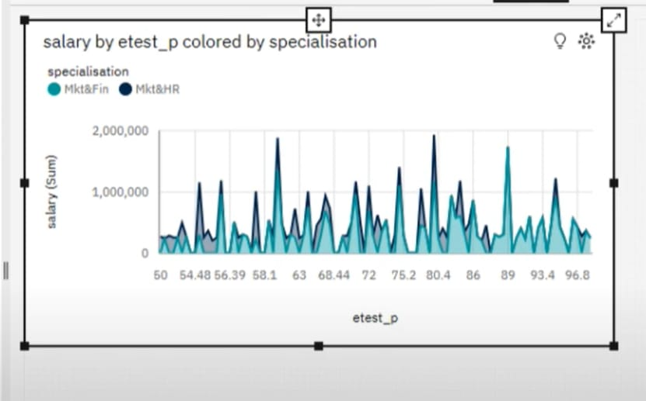 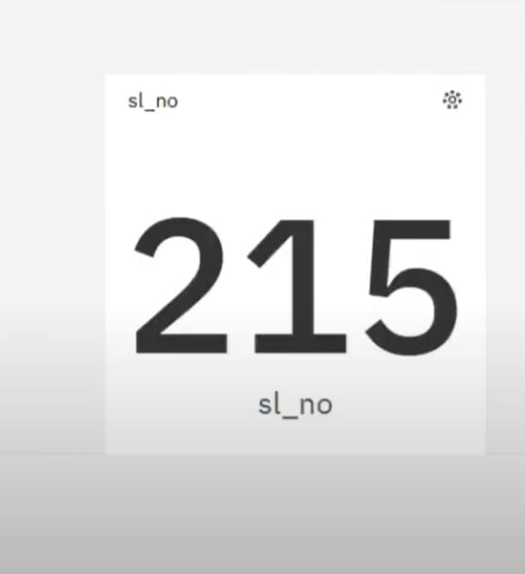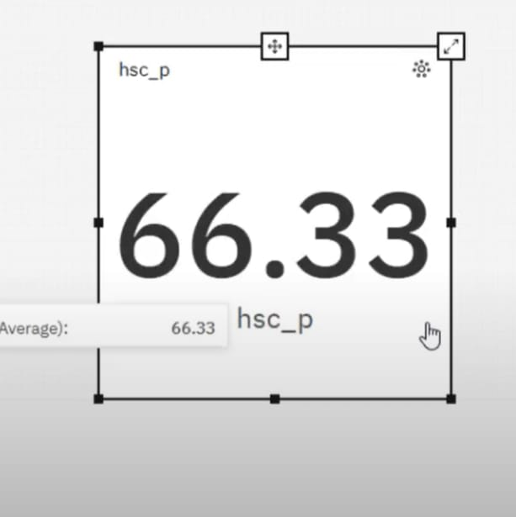

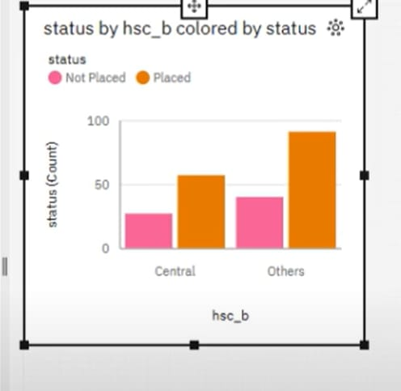

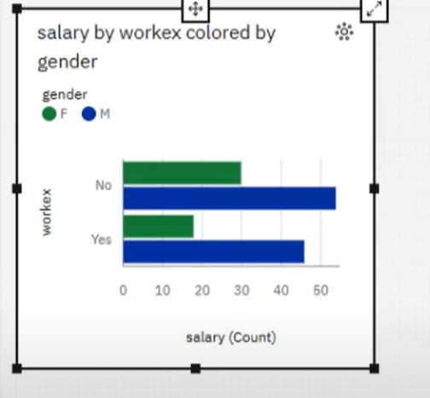

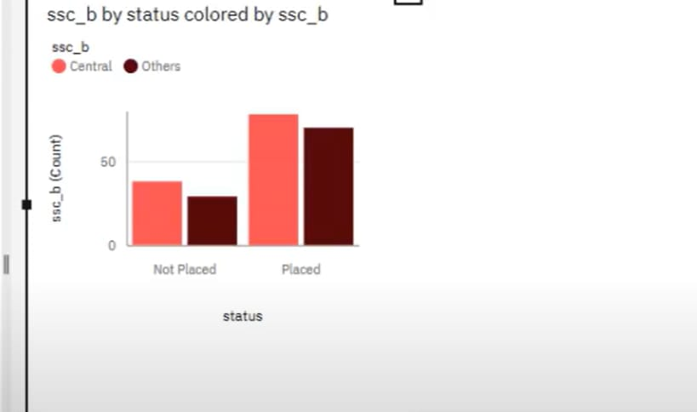

**CHAPTER 9**

**ADVANTAGES & DISADVANTAGES**

**9.1 Advantages**

1. Simplifies complex data
2. Reveals patterns and trends
3. Aids in decision making
4. Improves retention and engagement
5. Increases accessibility
6. Real-time monitoring
7. Identify areas that need attention or improvement
8. Predictive analysis
9. Enhances storytelling
10. Increases productivity
11. Risk management

**9.2 Disadvantages**

1. Regression analysis
2. Monte Carlo Simulation
3. Factor analysis
4. Cohort analysis
5. Cluster analysis
6. Time series analysis
7. Sentiment analysis

**CHAPTER 10**

**CONCLUSION**

Data analysis methods provide the mechanisms for turning raw data into insights that inform strategy. While statistical knowledge underpins their application, these techniques have moved far beyond the realm of simple regression models.

From simulation tools that test scenarios to complex neural networks that find hidden correlations, the data analysis toolkit has expanded enormously.

Though the ever-growing array of techniques may seem daunting, a focus on business needs simplifies the selection process. With the right expertise and methodology mix, they can repeatedly translate data into impactful conclusions that reduce uncertainty and power better decisions.

**CHAPTER 11**

**FUTURE SCOPE**

Consider expanding the sources of data to include more aspects of hotel operations. This could involve integrating data from new systems or external sources to provide a more comprehensive view of performance. Explore the implementation of advanced predictive analytics models to forecast future trends in the hotel industry. Predictive models can provide valuable insights for strategic planning.

Radisson Hotel Group is one of the world's largest and most dynamic hotel companies, with seven distinctive hotel brands and more than 1,400 hotels in operation and under development around the world. Targeting accelerated growth with its 5-year operating plan and aiming to be one of the three top-of-mind hotel companies in the world, the Group rebranded in 2018 and launched a new brand architecture – including new commercial drivers - to leverage the powerful brand awareness of Radisson.

The goal is To leverage the greater equity of the Radisson brand to drive up consumer awareness, while increasing the efficiency of global marketing spend and continuing to curate [exceptional digital customer experiences.](https://www.accenture.com/us-en/insights/song/customer-experience-index)

With direct-to-consumer channels ever more important in today’s hospitality industry, Radisson Hotels also wanted to drive more traffic to its branded website and enhance its ability to increase digital sales and create new cross-selling and up-selling opportunities.

**CHAPTER 12 APPENDIX**

**12 Source Code**

<!DOCTYPE html>

<html lang="en">

<head>

<meta charset="utf-8">

<meta content="width=device-width, initial-scale=1.0" name="viewport">

<title>Analytics Tool For Placements</title>

<meta content="" name="description">

<meta content="" name="keywords">

<!-- Favicons -->

<link href="assets/img/favicon.png" rel="icon">

<link href="assets/img/apple-touch-icon.png" rel="apple-touch-icon">

<!-- Google Fonts -->

<link href="https://fonts.googleapis.com/css?family=Open+Sans:300,300i,400,400i,600,600i,700,700i|Krub:300,300i,400,400i,500,500i,600,600i,700,700i|Poppins:300,300i,400,400i,500,500i,600,600i,700,700i" rel="stylesheet">

<!-- Vendor CSS Files -->

<link href="assets/vendor/aos/aos.css" rel="stylesheet">

<link href="assets/vendor/bootstrap/css/bootstrap.min.css" rel="stylesheet">

<link href="assets/vendor/bootstrap-icons/bootstrap-icons.css" rel="stylesheet">

<link href="assets/vendor/boxicons/css/boxicons.min.css" rel="stylesheet">

<link href="assets/vendor/glightbox/css/glightbox.min.css" rel="stylesheet">

<link href="assets/vendor/swiper/swiper-bundle.min.css" rel="stylesheet">

<!-- Template Main CSS File -->

<link href="assets/css/style.css" rel="stylesheet">

<!-- =======================================================

* Template Name: Bikin

* Updated: Sep 18 2023 with Bootstrap v5.3.2

* Template URL: https://bootstrapmade.com/bikin-free-simple-landing-page-template/

* Author: BootstrapMade.com

* License: https://bootstrapmade.com/license/

======================================================== -->

</head>

<body>

<!-- ======= Header ======= -->

<header id="header" class="fixed-top">

<div class="container d-flex align-items-center justify-content-between">

<h1 class="logo"><a href="index.html">Analytics Tool For Placements</a></h1>

<!-- Uncomment below if you prefer to use an image logo -->

<!-- <a href="index.html" class="logo"><img src="assets/img/logo.png" alt="" class="img-fluid"></a>-->

<nav id="navbar" class="navbar">

<ul>

<li><a class="nav-link scrollto active" href="#hero">Home</a></li>

<li><a class="nav-link scrollto" href="#dashbord">Dashbord</a></li>

<li><a class="nav-link scrollto " href="#story">story</a></li>

<li><a class="nav-link scrollto" href="#report">Report</a></li>

<li><a class="nav-link scrollto" href="#contact">Contact</a></li>

<i class="bi bi-list mobile-nav-toggle"></i>

</nav><!-- .navbar -->

</div>

</header><!-- End Header -->

<!-- ======= Hero Section ======= -->

<section id="hero" class="d-flex align-items-center">

<div class="container d-flex flex-column align-items-center justify-content-center" data-aos="fade-up">

<h1>Get ahead with Analytics Tool For Placements</h1>

<h2>We're serving up trusted insights and anonymous conversation, so you'll have the goods you need to succeed.</h2>

<a href="#about" class="btn-get-started scrollto">Get Started</a>

<img src="https://media.sproutsocial.com/uploads/2023/07/13-Competitor-Analysis-Tools-to-spy-on-your-competition-Final.jpg" class="img-fluid hero-img" alt="" data-aos="zoom-in" data-aos-delay="150">

</div>

</section><!-- End Hero -->

<main id="main">

<!-- ======= Features Section ======= -->

<section id="dashbord" class="features" data-aos="fade-up">

<div class="container">

<div class="section-title">

<h3>Dashbord</h3>

</div>

<iframe src="https://us1.ca.analytics.ibm.com/bi/?perspective=dashboard&amp;pathRef=.my_folders%2Fglass%2Bdoor%2Bjobs%2Fglass%2Bdoor%2Bjobs%2Bdashboard&amp;closeWindowOnLastView=true&amp;ui_appbar=false&amp;ui_navbar=false&amp;shareMode=embedded&amp;action=view&amp;mode=dashboard&amp;subView=model0000018b84e6794c_00000008" width="1350" height="900" frameborder="0" gesture="media" allow="encrypted-media" allowfullscreen=""></iframe>

</div>

</section><!-- End Features Section -->

<!-- ======= Steps Section ======= -->

<!-- End Steps Section -->

<!-- ======= Services Section ======= -->

<section id="story" class="services">

<div class="container" data-aos="fade-up">

<div class="section-title">

<h2>Story</h2>

</div>

<iframe src="https://us1.ca.analytics.ibm.com/bi/?perspective=story&amp;pathRef=.my_folders%2Fglass%2Bdoor%2Bjobs%2FStory%253A%2Bglass%2Bdoor%2Bjobs%2Bstory&amp;closeWindowOnLastView=true&amp;ui_appbar=false&amp;ui_navbar=false&amp;shareMode=embedded&amp;action=view&amp;sceneId=-1&amp;sceneTime=0" width="1350" height="900" frameborder="0" gesture="media" allow="encrypted-media" allowfullscreen=""></iframe>

</div>

</section><!-- End Services Section -->

<!-- ======= Portfolio Section ======= -->

<section id="report" class="portfolio">

<div class="container" data-aos="fade-up">

<div class="section-title">

<h2>Report</h2>

</div>

<iframe src="https://us1.ca.analytics.ibm.com/bi/?pathRef=.my_folders%2Fglass%2Bdoor%2Bjobs%2Fglass%2Bdoor%2Bjobs%2Breport&amp;closeWindowOnLastView=true&amp;ui_appbar=false&amp;ui_navbar=false&amp;shareMode=embedded&amp;action=run&amp;format=HTML&amp;prompt=false" width="1350" height="900" frameborder="0" gesture="media" allow="encrypted-media" allowfullscreen=""></iframe>

</div>

</section><!-- End Portfolio Section -->

<!-- ======= Testimonials Section ======= -->

<!-- End Testimonials Section -->

<!-- ======= Team Section ======= -->

<section id="team" class="team">

<div class="container" data-aos="fade-up">

<div class="section-title">

<h2>Team</h2>

</div>

<div class="row">

<div class="col-xl-3 col-lg-4 col-md-6" data-aos="fade-up" data-aos-delay="100">

<div class="member">

<img src="assets/img/team/team-1.jpg" class="img-fluid" alt="">

<div class="member-info">

<div class="member-info-content">

<h4>MALLE ANIL</h4>

<span>Team Leader</span>

</div>

<div class="social">

<a href=""><i class="bi bi-twitter"></i></a>

<a href=""><i class="bi bi-facebook"></i></a>

<a href=""><i class="bi bi-instagram"></i></a>

<a href=""><i class="bi bi-linkedin"></i></a>

</div>

</div>

</div>

</div>

<div class="col-xl-3 col-lg-4 col-md-6" data-aos="fade-up" data-aos-delay="200">

<div class="member">

<img src="assets/img/team/team-2.jpg" class="img-fluid" alt="">

<div class="member-info">

<div class="member-info-content">

<h4>MARUPURU MOHANKRISHNA</h4>

<span>Team Member</span>

</div>

<div class="social">

<a href=""><i class="bi bi-twitter"></i></a>

<a href=""><i class="bi bi-facebook"></i></a>

<a href=""><i class="bi bi-instagram"></i></a>

<a href=""><i class="bi bi-linkedin"></i></a>

</div>

</div>

</div>

</div>

</div>

</div>

</section><!-- End Team Section -->

<!-- ======= Contact Section ======= -->

<section id="contact" class="contact section-bg">

<div class="container" data-aos="fade-up">

<div class="section-title">

<h2>Contact</h2>

</div>

<div class="row">

<div class="col-lg-6">

<div class="row">

<div class="col-md-12">

<div class="info-box">

<i class="bx bx-map"></i>

<h3>Our Address</h3>

<p>Arjun College Of Technology,coimbatore</p>

</div>

</div>

<div class="col-md-6">

<div class="info-box mt-4">

<i class="bx bx-envelope"></i>

<h3>Email Us</h3>

<p>malle.anil123@gmail.com<br>marupurumohankrishnachowdary@gmail.com</p>

</div>

</div>

<div class="col-md-6">

<div class="info-box mt-4">

<i class="bx bx-phone-call"></i>

<h3>Call Us</h3>

<p>+91 6302588973<br>+91 7330663226</p>

</div>

</div>

</div>

</div>

<div class="col-lg-6 mt-4 mt-md-0">

<form action="forms/contact.php" method="post" role="form" class="php-email-form">

<div class="row">

<div class="col-md-6 form-group">

<input type="text" name="name" class="form-control" id="name" placeholder="Your Name" required>

</div>

<div class="col-md-6 form-group mt-3 mt-md-0">

<input type="email" class="form-control" name="email" id="email" placeholder="Your Email" required>

</div>

</div>

<div class="form-group mt-3">

<input type="text" class="form-control" name="subject" id="subject" placeholder="Subject" required>

</div>

<div class="form-group mt-3">

<textarea class="form-control" name="message" rows="5" placeholder="Message" required></textarea>

</div>

<div class="my-3">

<div class="loading">Loading</div>

<div class="error-message"></div>

<div class="sent-message">Your message has been sent. Thank you!</div>

</div>

<div class="text-center"><button type="submit">Send Message</button></div>

</form>

</div>

</div>

</div>

</section><!-- End Contact Section -->

</main><!-- End #main -->

<!-- ======= Footer ======= -->

<footer id="footer">

<div class="footer-top">

<div class="container">

<div class="row">

<div class="col-lg-3 col-md-6 footer-contact">

<h3>Analytics Tool For Placements</h3>

<p>

Arjun College Of Technology<br>

Coimbatore<br>

India <br><br>

<strong>Phone:</strong> +91 6302588973<br>

<strong>Email:</strong> malle.anil123@.com<br>

</p>

</div>

<div class="col-lg-2 col-md-6 footer-links">

<h4>Useful Links</h4>

<ul>

<li><i class="bx bx-chevron-right"></i> <a href="#">Home</a></li>

<li><i class="bx bx-chevron-right"></i> <a href="#">Contact Us</a></li>

<li><i class="bx bx-chevron-right"></i> <a href="#">Dashbord</a></li>

<li><i class="bx bx-chevron-right"></i> <a href="#">Terms of service</a></li>

<li><i class="bx bx-chevron-right"></i> <a href="#">Privacy policy</a></li>

</ul>

</div>

<div class="col-lg-3 col-md-6 footer-links">

<h4>Our Services</h4>

<ul>

<li><i class="bx bx-chevron-right"></i> <a href="#">Web Design</a></li>

<li><i class="bx bx-chevron-right"></i> <a href="#">Web Development</a></li>

<li><i class="bx bx-chevron-right"></i> <a href="#">Product Management</a></li>

<li><i class="bx bx-chevron-right"></i> <a href="#">Artificial Intelligence</a></li>

<li><i class="bx bx-chevron-right"></i> <a href="#">Data Science</a></li>

</ul>

</div>

<div class="col-lg-4 col-md-6 footer-newsletter">

<h4>Join Our Newsletter</h4>

<form action="" method="post">

<input type="email" name="email"><input type="submit" value="Subscribe">

</form>

</div>

</div>

</div>

</div>

<div class="container d-md-flex py-4">

<div class="me-md-auto text-center text-md-start">

<div class="copyright">

&copy; Copyright <strong><span>Analytics Tool For Placements</span></strong>. All Rights Reserved

</div>

<div class="credits">

<!-- All the links in the footer should remain intact. -->

<!-- You can delete the links only if you purchased the pro version. -->

<!-- Licensing information: https://bootstrapmade.com/license/ -->

<!-- Purchase the pro version with working PHP/AJAX contact form: https://bootstrapmade.com/bikin-free-simple-landing-page-template/ -->

Designed by <a href="https://bootstrapmade.com/">BootstrapMade</a>

</div>

</div>

<div class="social-links text-center text-md-right pt-3 pt-md-0">

<a href="#" class="twitter"><i class="bx bxl-twitter"></i></a>

<a href="#" class="facebook"><i class="bx bxl-facebook"></i></a>

<a href="#" class="instagram"><i class="bx bxl-instagram"></i></a>

<a href="#" class="google-plus"><i class="bx bxl-skype"></i></a>

<a href="#" class="linkedin"><i class="bx bxl-linkedin"></i></a>

</div>

</div>

</footer><!-- End Footer -->

<div id="preloader"></div>

<a href="#" class="back-to-top d-flex align-items-center justify-content-center"><i class="bi bi-arrow-up-short"></i></a>

<!-- Vendor JS Files -->

<script src="assets/vendor/aos/aos.js"></script>

<script src="assets/vendor/bootstrap/js/bootstrap.bundle.min.js"></script>

<script src="assets/vendor/glightbox/js/glightbox.min.js"></script>

<script src="assets/vendor/isotope-layout/isotope.pkgd.min.js"></script>

<script src="assets/vendor/swiper/swiper-bundle.min.js"></script>

<script src="assets/vendor/php-email-form/validate.js"></script>

<!-- Template Main JS File -->

<script src="assets/js/main.js"></script>

</body>

</html>

**12.2 GitHub & Project Demo Link**

**https://github.com/Anil143devil/Anil143devil/upload/main**

https://drive.google.com/file/d/1E3XHCvs-MJmCeI-NWO8bE2uj9YUbrI8q/view?usp=drive_link